Prior Knowledge

Supervised Machine Learning:
Supervised learning is a machine learning method in which models are trained using labeled data. In supervised learning, models need to find the mapping function to map the input variable (X) with the output variable (Y).
Example: Suppose we have an image of different types of fruits. The task of our supervised learning model is to identify the fruits and classify them accordingly. So to identify the image in supervised learning, we will give the input data as well as output for that, which means we will train the model by the shape, size, color, and taste of each fruit. Once the training is completed, we will test the model by giving the new set of fruit. The model will identify the fruit and predict the output using a suitable algorithm.

Unsupervised Machine Learning:
Unsupervised learning is another machine learning method in which patterns inferred from the unlabeled input data. The goal of unsupervised learning is to find the structure and patterns from the input data. Unsupervised learning does not need any supervision. Instead, it finds patterns from the data by its own.Unsupervised learning can be used for two types of problems: Clustering and Association.
Example: To understand the unsupervised learning, we will use the example given above. So unlike supervised learning, here we will not provide any supervision to the model. We will just provide the input dataset to the model and allow the model to find the patterns from the data. With the help of a suitable algorithm, the model will train itself and divide the fruits into different groups according to the most similar features between them.

Decision Tree :
A decision tree is a non-parametric supervised learning algorithm, which is utilized for both classification and regression tasks. It has a hierarchical, tree structure, which consists of a root node, branches, internal nodes and leaf nodes. f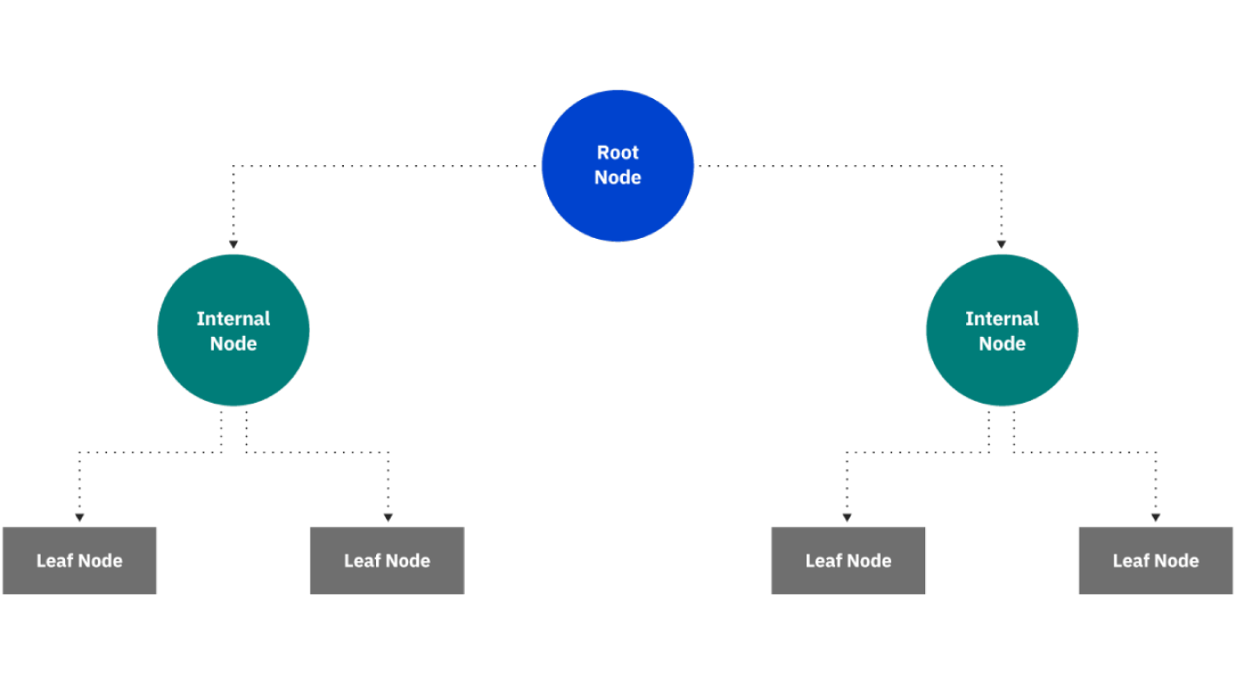 y insta
As you can see from the diagram above, a decision tree starts with a root node, which does not have any incoming branches. The outgoing branches from the root node then feed into the internal nodes, also known as decision nodes. Based on the available features, both node types conduct evaluations to form homogenous subsets, which are denoted by leaf nodes, or terminal nodes. The leaf nodes represent all the possible outcomes within the dataset. As an example, let’s imagine that you were trying to assess whether or not you should go surf, you may use the following decision rules to make a choice:
Types of Decision Trees es by sorting them down the tree from the root to some
- ID3: Ross Quinlan is credited within the development of ID3, which is shorthand for “Iterative Dichotomiser 3.” This algorithm leverages entropy and information gain as metrics to evaluate candidate splits. Some of Quinlan’s research on this algorithm from 1986 can be found here (PDF, 1.4 MB) (link resides outside of ibm.com).
- C4.5: This algorithm is considered a later iteration of ID3, which was also developed by Quinlan. It can use information gain or gain ratios to evaluate split points within the decision trees.
- CART: The term, CART, is an abbreviation for “classification and regression trees” and was introduced by Leo Breiman. This algorithm typically utilizes Gini impurity to identify the ideal attribute to split on. Gini impurity measures how often a randomly chosen attribute is misclassified. When evaluating using Gini impurity, a lower value is more ideal.

Classification of clustering :
Clustering is an unsupervised technique. With clustering, the algorithm tries to find a pattern in data sets without labels associated with it. This could be a clustering of buying behaviour of customers. Features for this would be the household income, age, … and clusters of different consumers could then be built.
he next one is classification. In contrast to clustering, classification is a supervised technique. Classification algorithms look at existing data and predicts what a new data belongs to. Classification is used for spam for years now and these algorithms are more or less mature in classifying something as spam or not. With machine data, it could be used to predict a material quality by several known parameters (e.g. humidity, strength, color, … ). The output of the material prediction would then be the quality type (either “good” or “bad” or a number in a defined space like 1-10).

Classification of regression :
Regression is often confused with clustering, but it is still different from it. With a regression, no classified labels (such as good or bad, spam or not spam, …) are predicted. Instead, regression outputs continuous, often unbound, numbers. This makes it useful for financial predictions and alike. A common known sample is the prediciton of housing prices, where several values (FEATURES!) are known, such as distance to specific landmarks, plot size,… The algorithms could then predict a price for your house and the amount you can sell it for.

